Getting Started with CIWC
No matter your experience level there is a place for you in CIWC. We are a very active club. First of all we are a teaching club and offer lots of possibilities for learning and advancing your outdoor knowledge and skills. Beyond that we offer classes, workshops and trips at all levels from beginner to higher end. We also have volunteer activities.
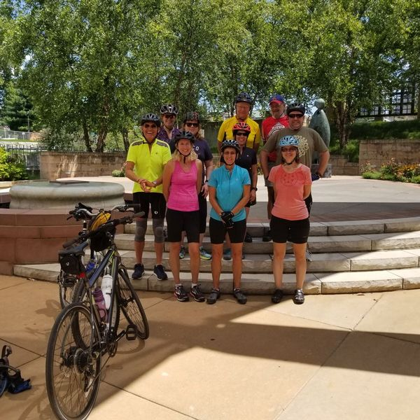
For beginners, the best way to start is with events where you can meet our regular members and also those considering membership. We have day events such as day hikes, day paddles and day biking events. Day events like this do not require formal (dues payment) membership and are there for you to be able to evaluate the club. Many of our day events are posted on Meetup (see link below). And several times a year we have social events that are free and open to the public, such as a speaker presenting / talking about a unique experience he or she had backpacking, paddling, etc. We’ve had speakers talk about hiking around Ireland, backpacking in New Zealand, Paddling in the Arctic and trekking to Machu Pichu in South America or even doing the 2100 mile Appalachian Trail.

Urban Bike Event in Indianapolis

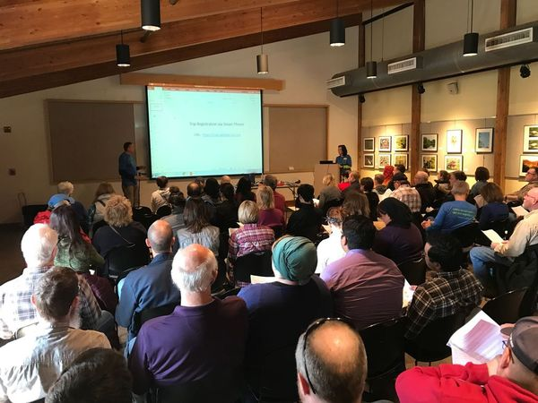
In March of every year we offer our annual beginning backpacking workshop at Holliday Park in Indianapolis. It’s run like seminar with short talks plus we have “show and tell” stations throughout the building. This event is free and well publicized and perfect for the beginner to attend. At the event we release a list of easy beginning backpacking trips – one night somewhere in Indiana that will take place in April, May or June. Experienced leaders will expose you to the basics of overnight camping in a venue away from cars. We can loan you a tent or backpack if you do not have one.
As far as our regular trips, we have weekend trips, 3-4 night trips and week-long trips. These can be within Indiana or across the nation and sometimes into Canada. CIWC owns a full size van in which we can travel to surrounding states (usually a day’s drive) for our adventures. There are also a number of “fly trips” each year to western states or other distant locations. All of our trips are led by experienced leaders who have received various levels of training including basic first aid or basic wilderness first aid.
We also have classes beyond the beginner backpacking workshop. Those may include classes in navigation, camp-craft skills, and as mentioned above, first aid and CPR.
Also check out our Reservation and Cancellation Policy as it applies to our trips. Just go back to the Club Info Tab.
Our Regular events are listed here on the website under EVENTS and day events are shown on Meetup. We share cool things on Facebook.
Our Meetup Site: https://www.meetup.com/CIWCLUB-ORG/
Facebook Page: https://www.facebook.com/CIWClub/

RRH 10/28/2019

